- Tạo EBS volume & Attach volume vào Instance & Mount volume vào instance
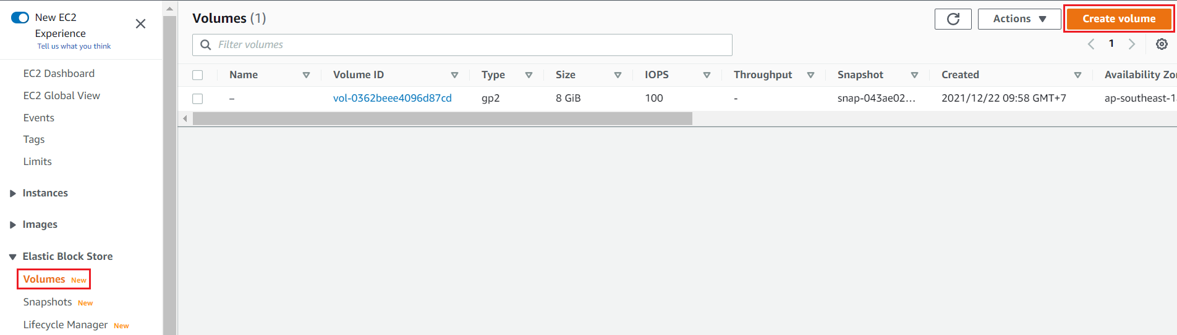  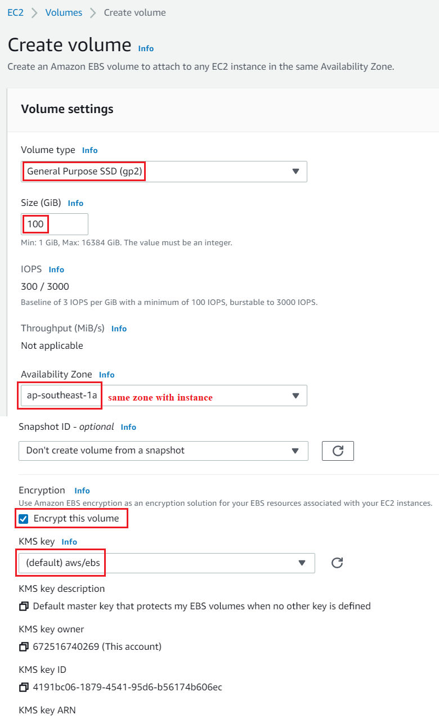  Tạo EBS Volume | 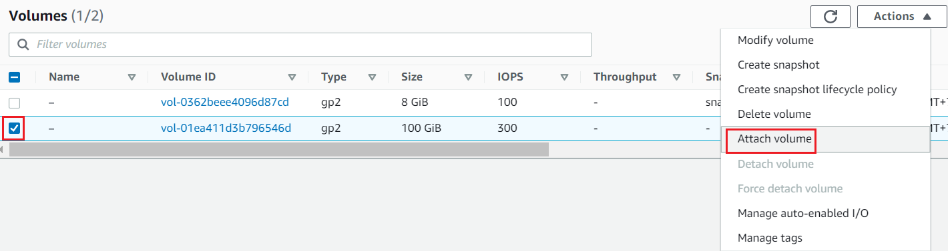  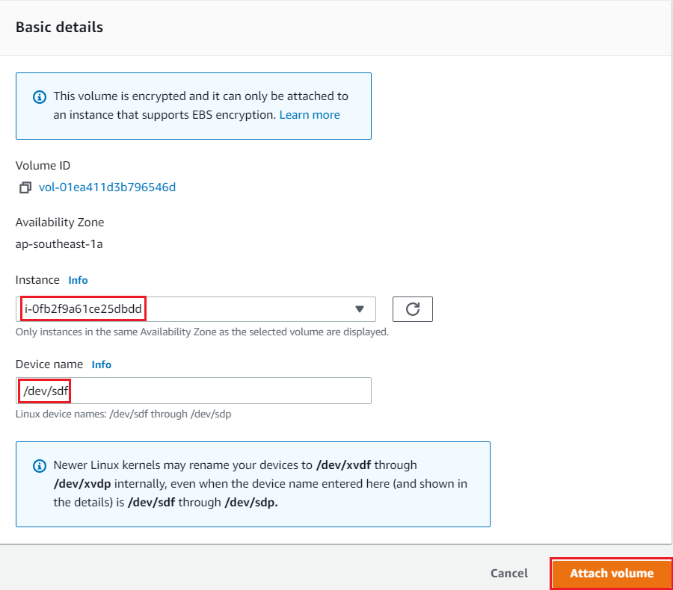  Attach volume vào Instance  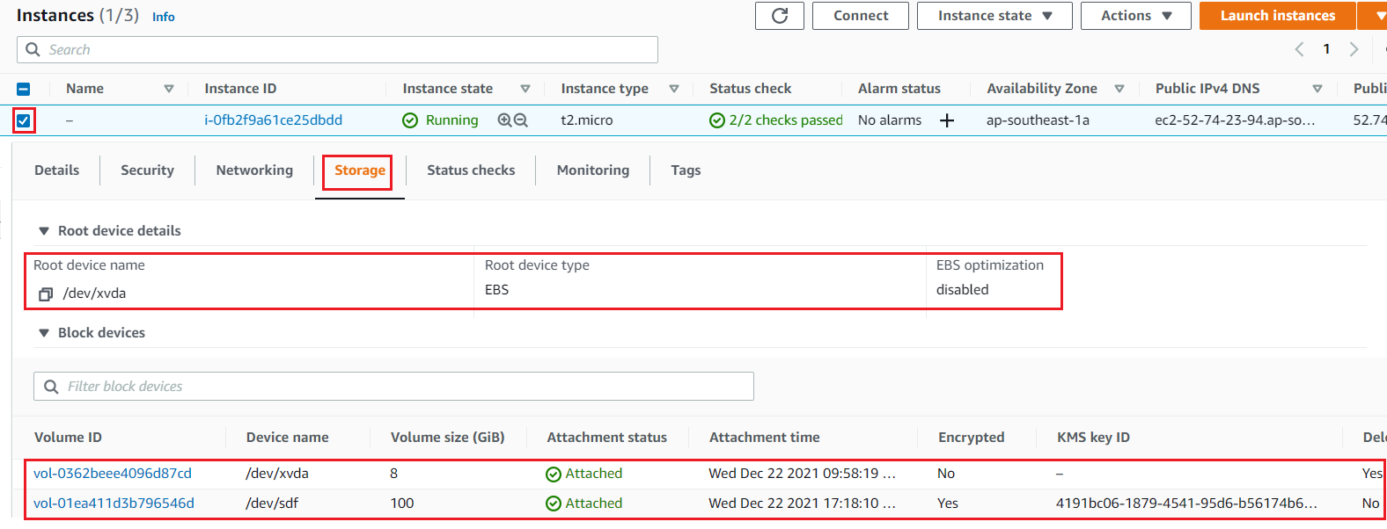  Result
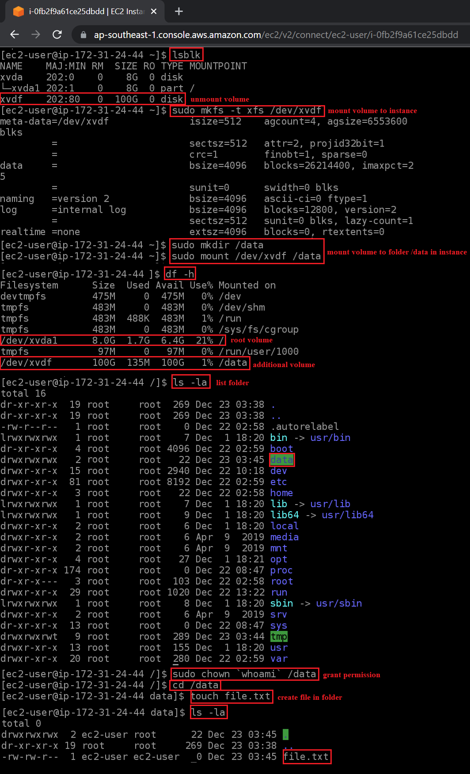
Mount volume vào instance
- Tạo Snapshot thủ công, restore instance, tạo AMI từ snapshot
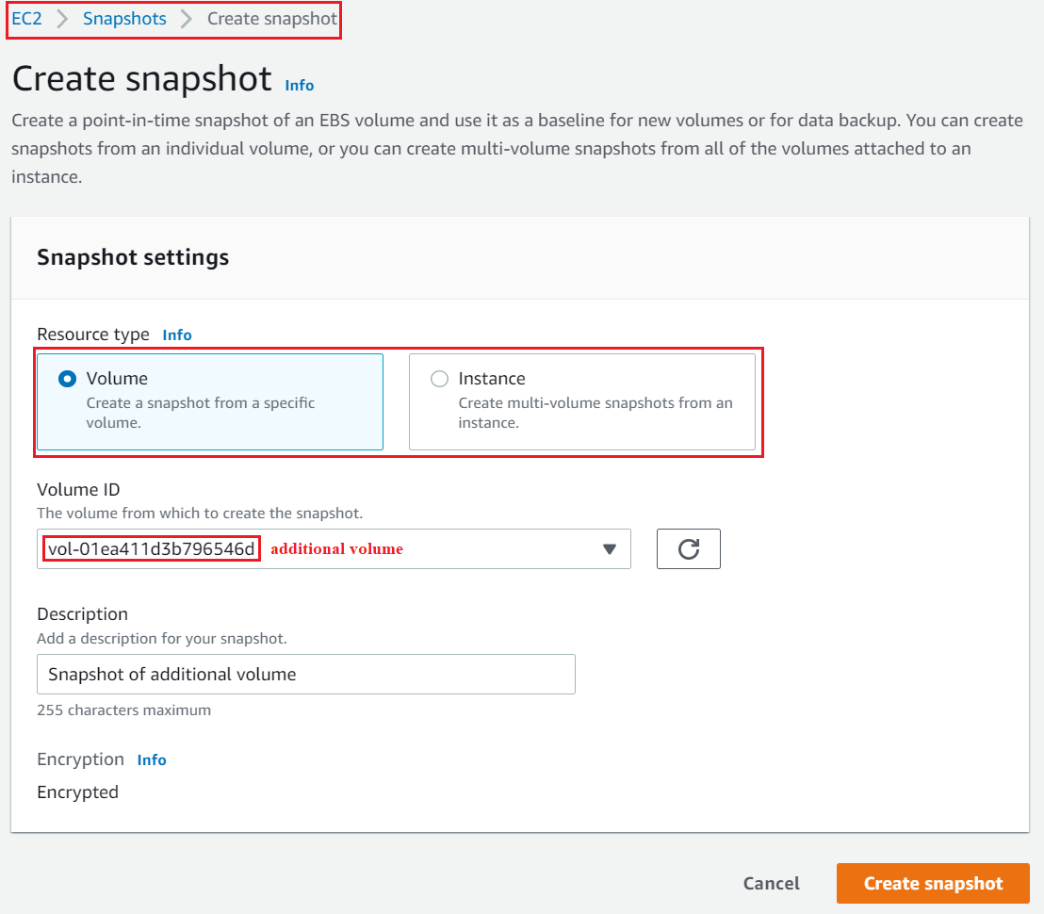  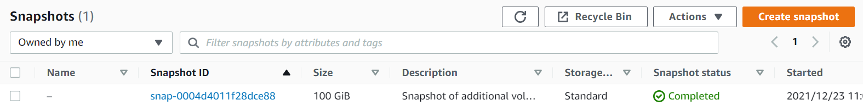  Tạo snapshot thủ công | 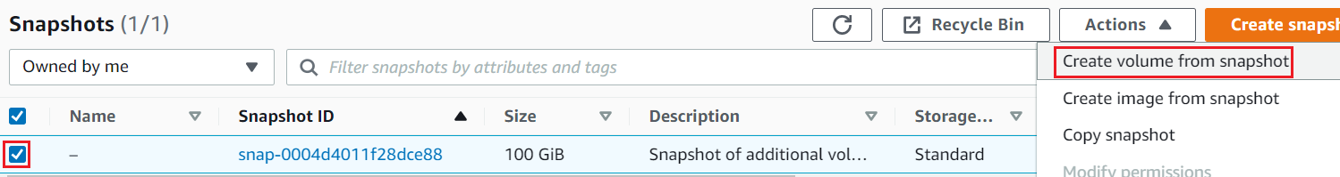  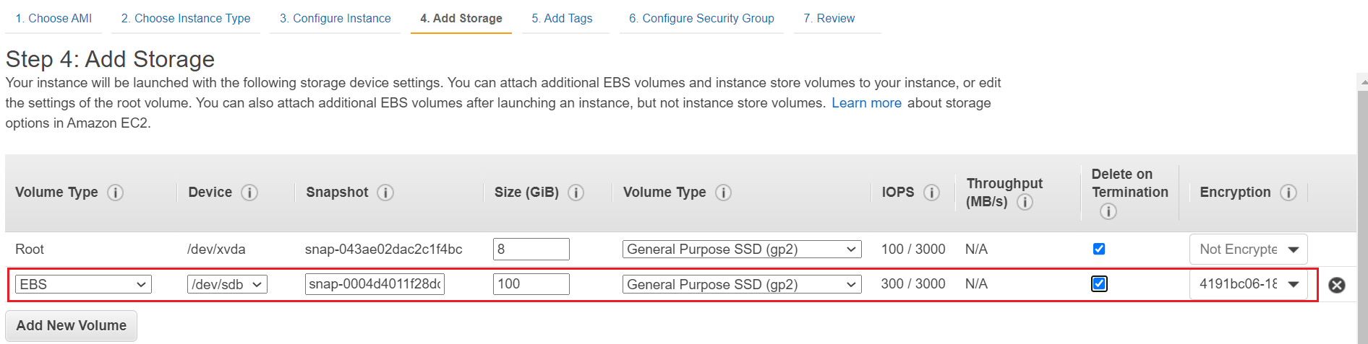  Restore instance  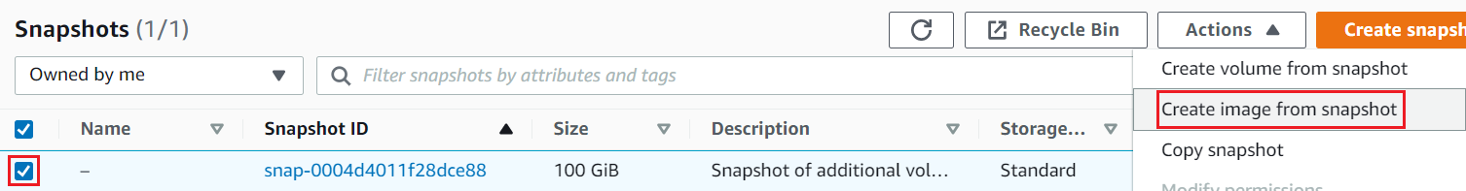  Tạo AMI từ snapshot

- Tạo Snapshot sử dụng Lifecycle Manager
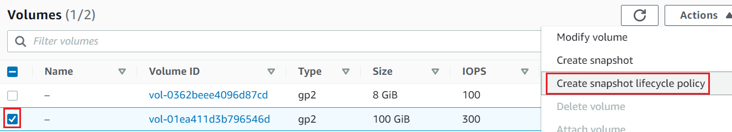
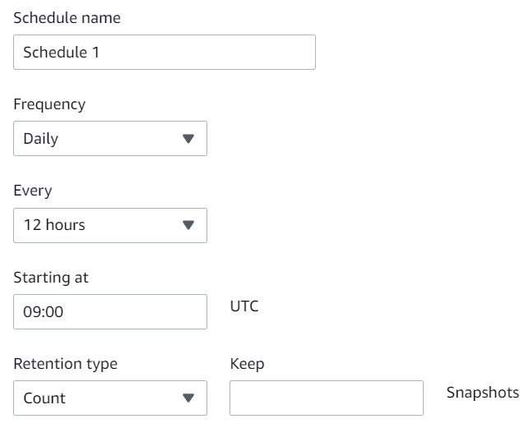

- Other
  - Instance store
    - Add thêm instance store vào AMI, Instance
https://docs.aws.amazon.com/AWSEC2/latest/UserGuide/add-instance-store-volumes.html
  - EBS
    - EBS volume
https://docs.aws.amazon.com/AWSEC2/latest/UserGuide/ebs-volumes.html
    - Snapshot
https://docs.aws.amazon.com/AWSEC2/latest/UserGuide/EBSSnapshots.html
    - Lifecycle Manager
https://docs.aws.amazon.com/AWSEC2/latest/UserGuide/snapshot-lifecycle.html
    - CloudWatch
https://docs.aws.amazon.com/AWSEC2/latest/UserGuide/using_cloudwatch_ebs.html

- Reference

